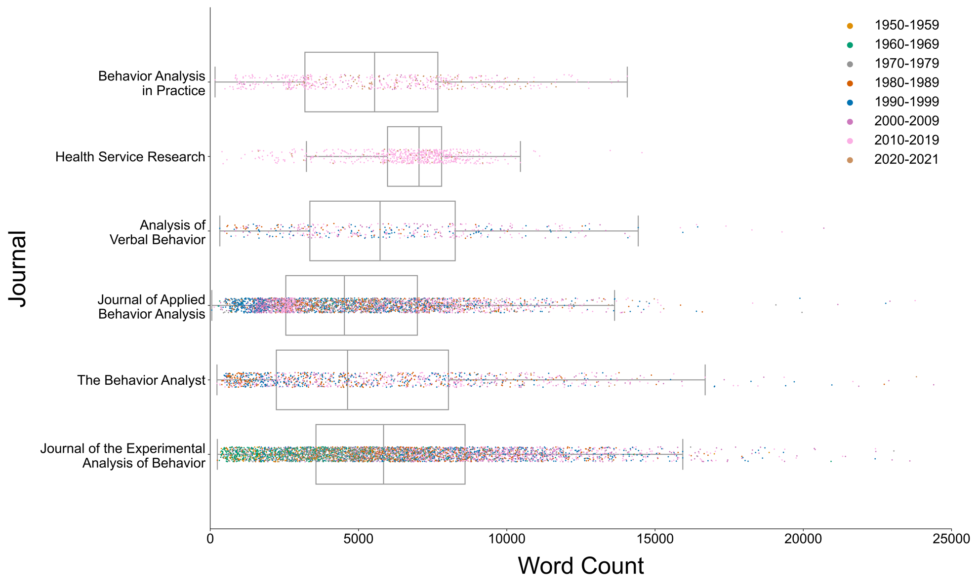

**Figure 1**. Box-and-strip plots of article word counts for each journal in the current corpus. Each marker corresponds to a single publication in that journal. Colors correspond to the decade of publication (see legend).

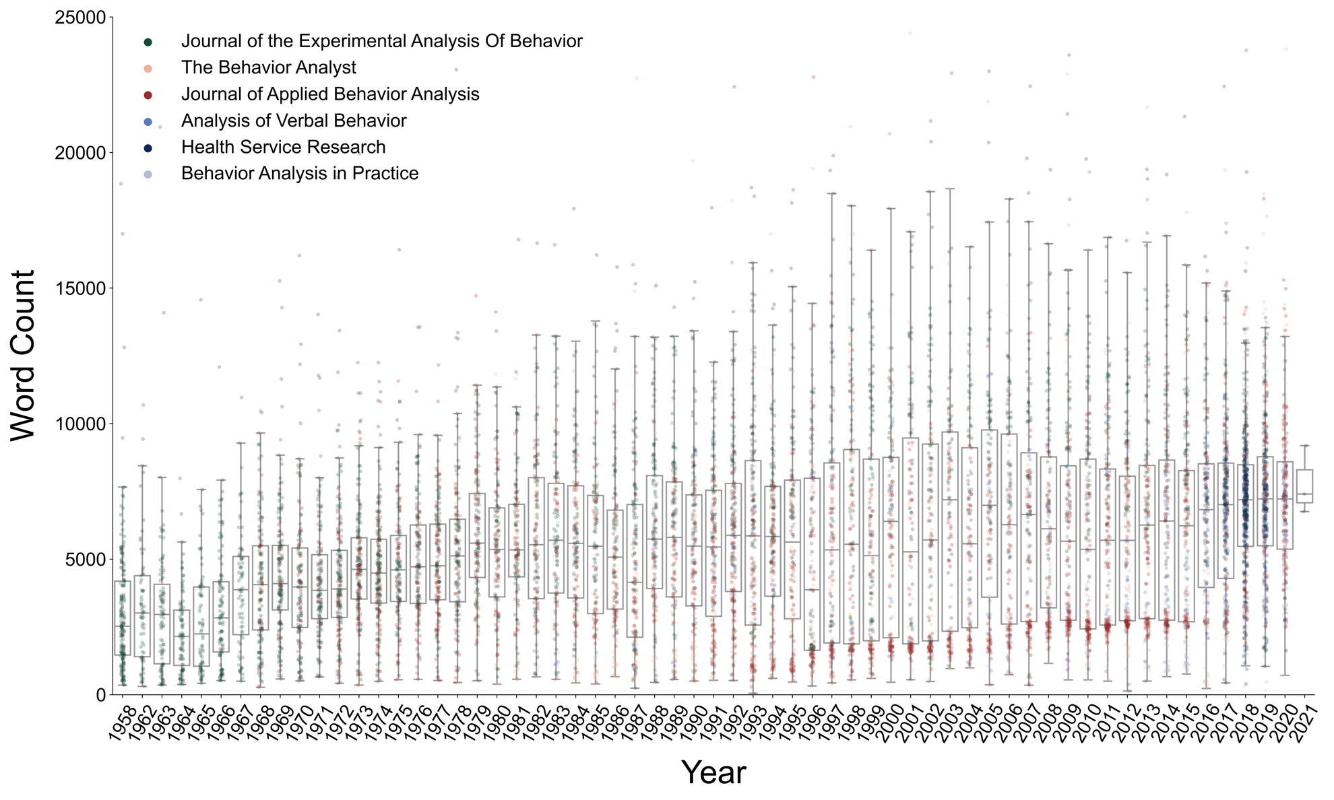

**Figure 2**. Box-and-strip plots of the word count of journals for each calendar year. Each marker corresponds to a single article published in that calendar year. Colors correspond to the specific journal in which the article was published (see legend).

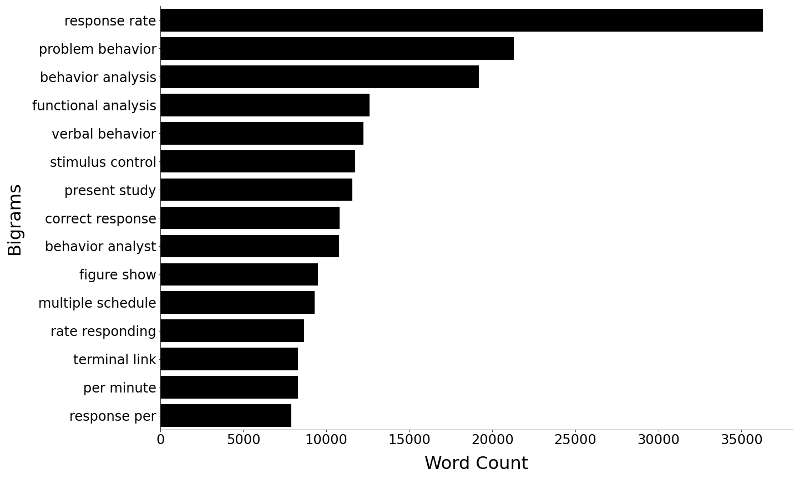

**Figure 3**. The top 15 most frequent bigrams across behavior analytic articles in the corpus derived for this study.

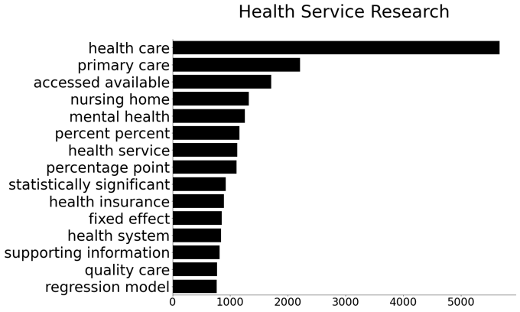 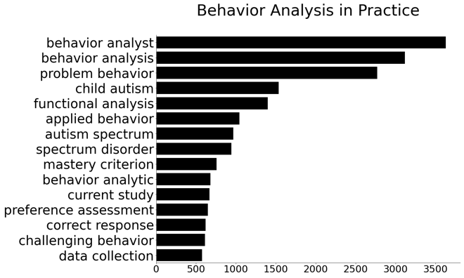

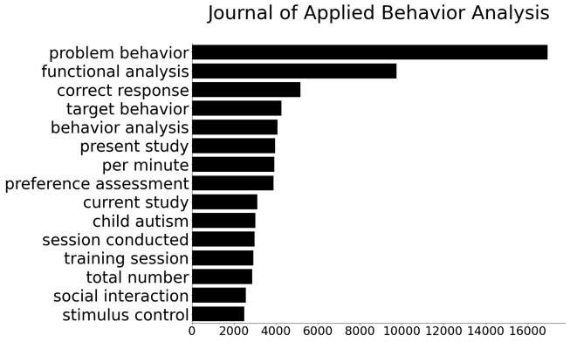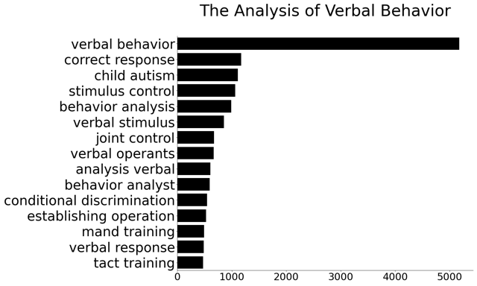

Bigrams

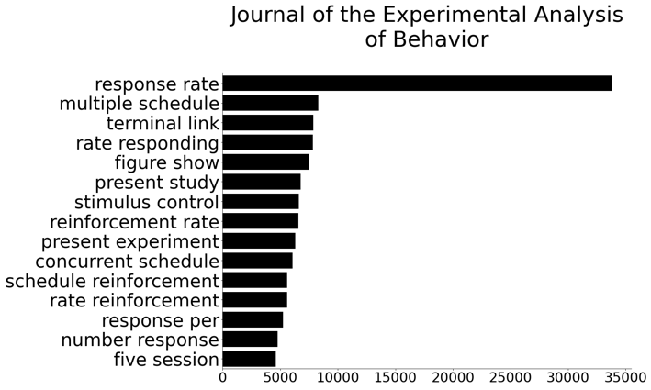 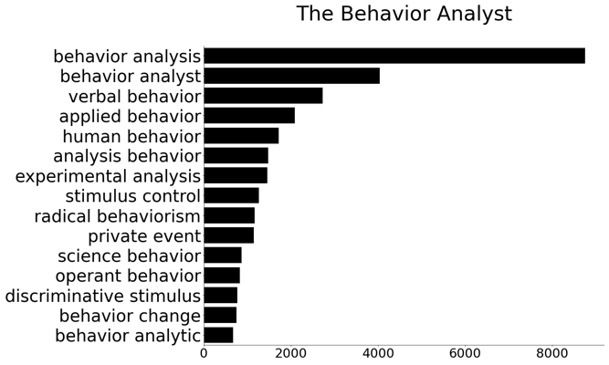

Word Count

**Figure 4**. The top 15 most frequent bigrams across Health Service Research (Top Left), Behavior Analysis in Practice (Top Right), Journal of Applied Behavior Analysis (Middle Left), The Analysis of Verbal Behavior (Middle Right), Journal of the Experimental Analysis of Behavior (Bottom Left), and The Behavior Analyst/Perspective on Behavior Science (Bottom Right).



**Figure 5**. Scatterplot of the top 500 words from the journal *Health Service Research* compared to all behavior analytic journals. The y-axis shows the relative frequency with which the words are used in *Health Service Research* and the x-axis shows the relative frequency with which the words are used in all behavior analytic journals.

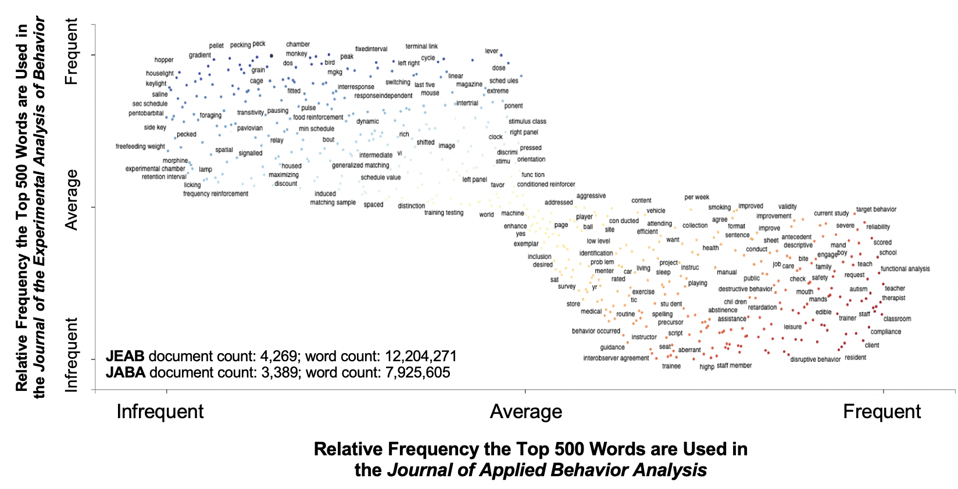

**Figure 6**. Scatter text of the top 500 words from the Journal of the Experimental Analysis of Behavior (JEAB) and the Journal of Applied Behavior Analysis (JABA). The y-axis shows the relative frequency with which the words are used in JEAB and the x-axis shows the relative frequency with which the words are used in JABA.

Raw files / images

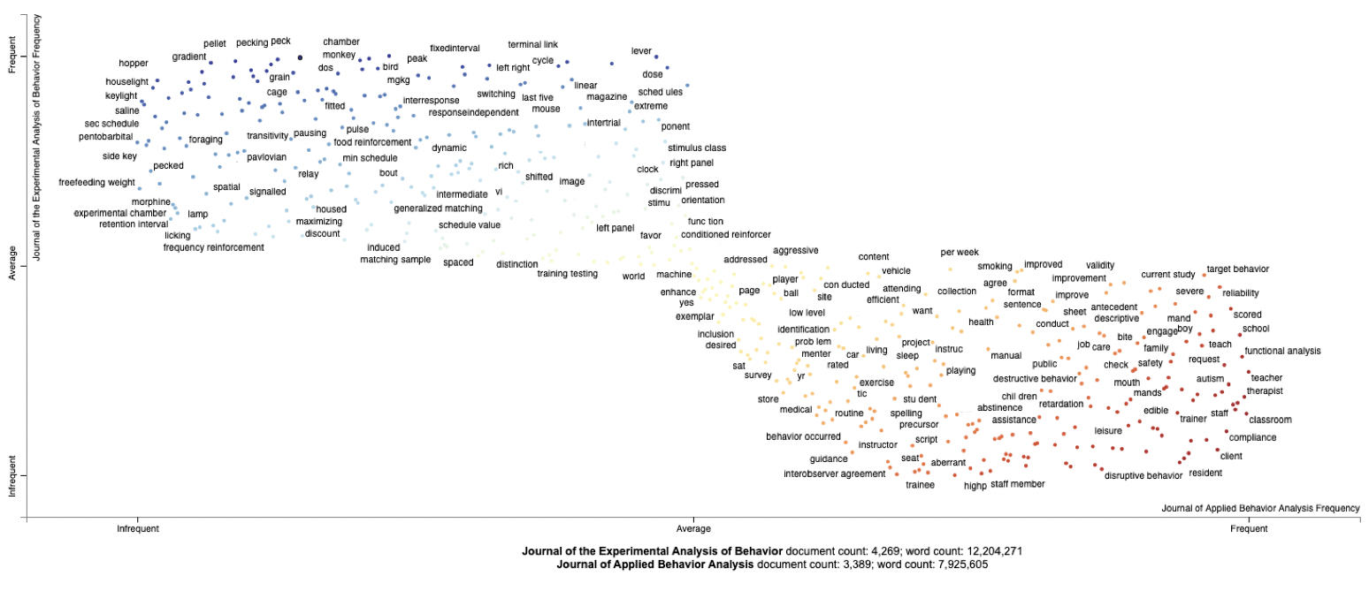

**JEAB** document count: 4,269; word count: 12,204,271

**JABA** document count: 3,389; word count: 7,925,605

**Relative Frequency the Top 500 Words are Used in**

**the *Journal of the Experimental Analysis of Behavior***

Infrequent Average Frequent

Infrequent Average Frequent

**Relative Frequency the Top 500 Words are Used in**

**the *Journal of Applied Behavior Analysis***

